Assignment -4 Docker and kubernetes

|  |  |
| --- | --- |
| Assignment Date | 10 October 2022 |
| Student Name | S prithishika |
| Student Roll Number | 922119104031 |
| Maximum Marks | 2 Marks |

Question-1:

pull an image from docker hub and run it in docker playground.

1. **pull an image from docker hub**

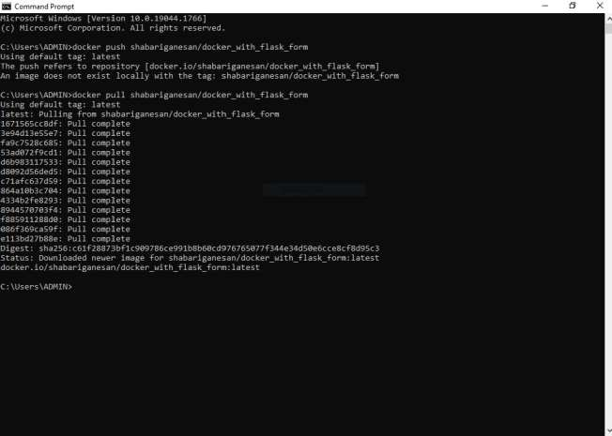

1. **runt it in docker playground**

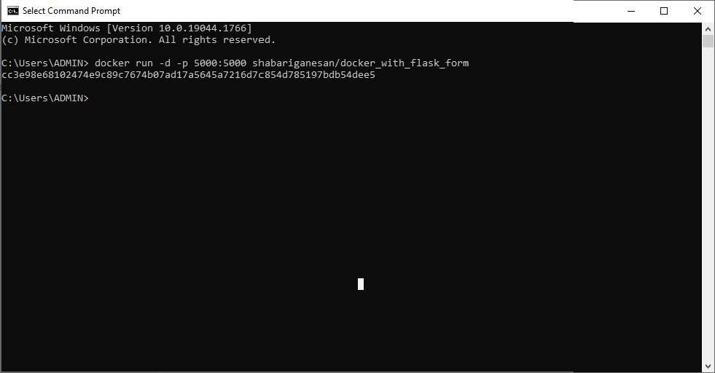

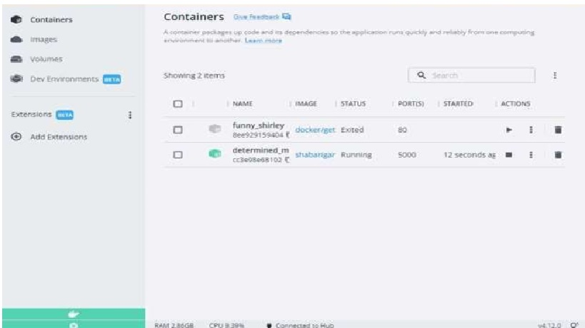

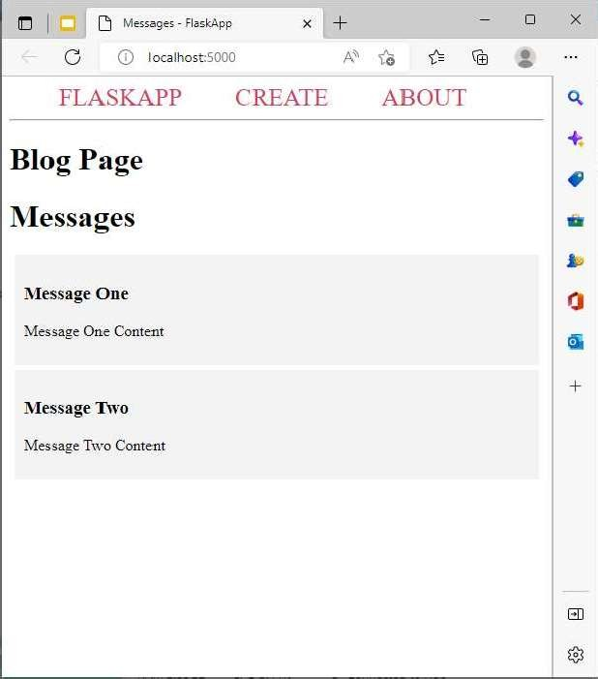

Question-2:

Create a docker file for the jobportal application and deploy it in docker application.

1. **Creating a docker file for the jobportal application**

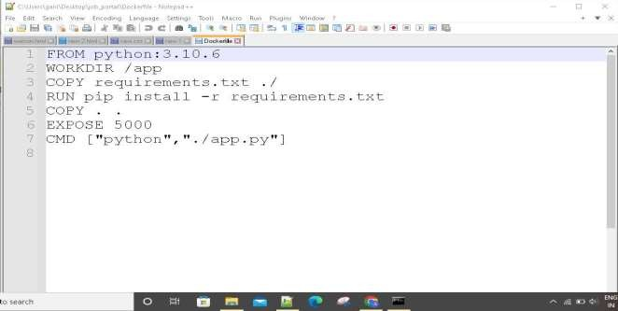

1. **deploy in in dokcer application**

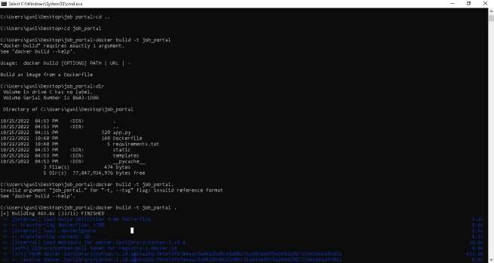

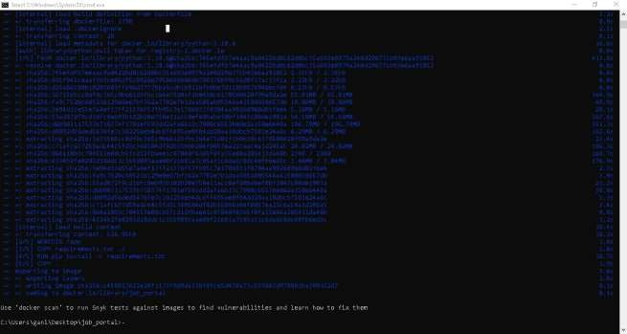



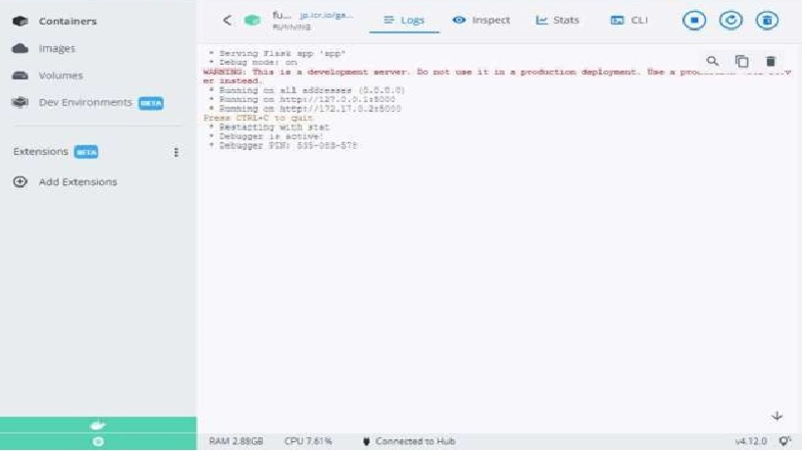

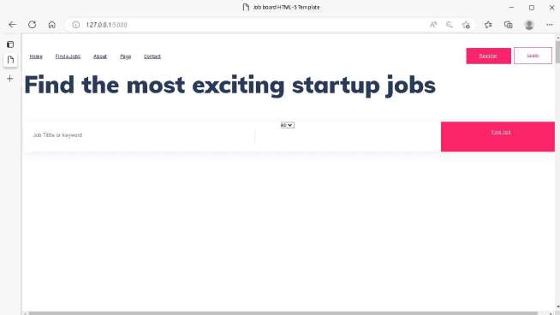

**running in docker desktop 1**

Question-3:Create aIbm container registry and deploy helloworld app or jobportalapp

1. **create a ibm container registry**

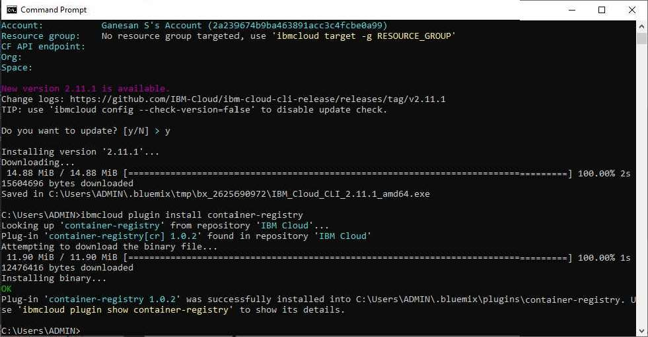

1. **deployhelloworld or jobportal**

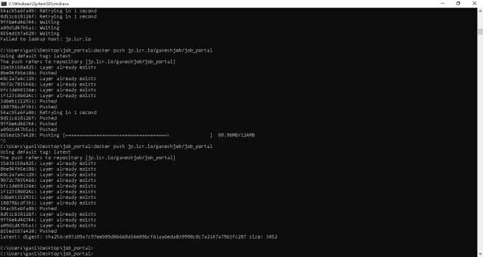

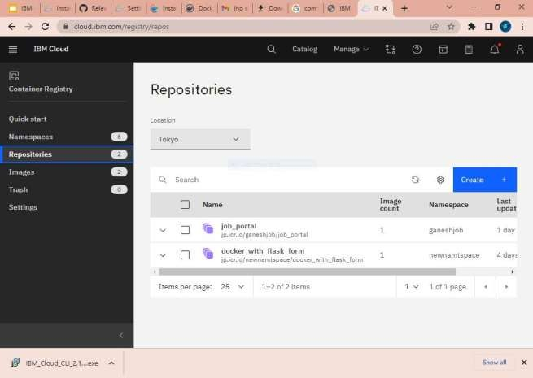

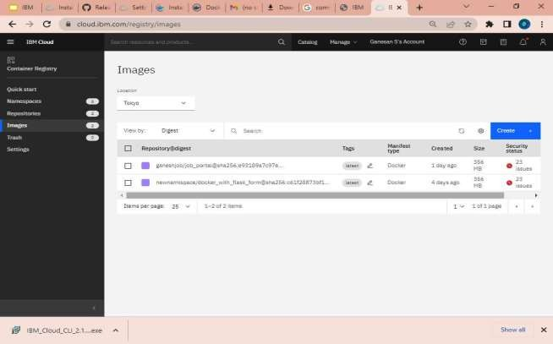

Question-4: Create a kubernetes cluster in ibm cloud and deploy helloworld image or jobportal image and also expose the same app to run in noteport

1. **Creating a kubernetes cluster in ibm cloud**

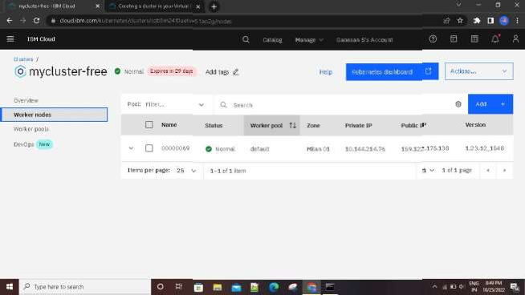

1. **deploy helloworld image or jobportal image and also expose the same app to run in noteport**

